Fundamentals of Computer Science
Homework Set 8
December 3, 2025
- (5’) In this question, we use a breadth-first search (BFS) approach to solve the maze problem shown in the figure (the initial state is (1,1) and the target state is (4,4)).
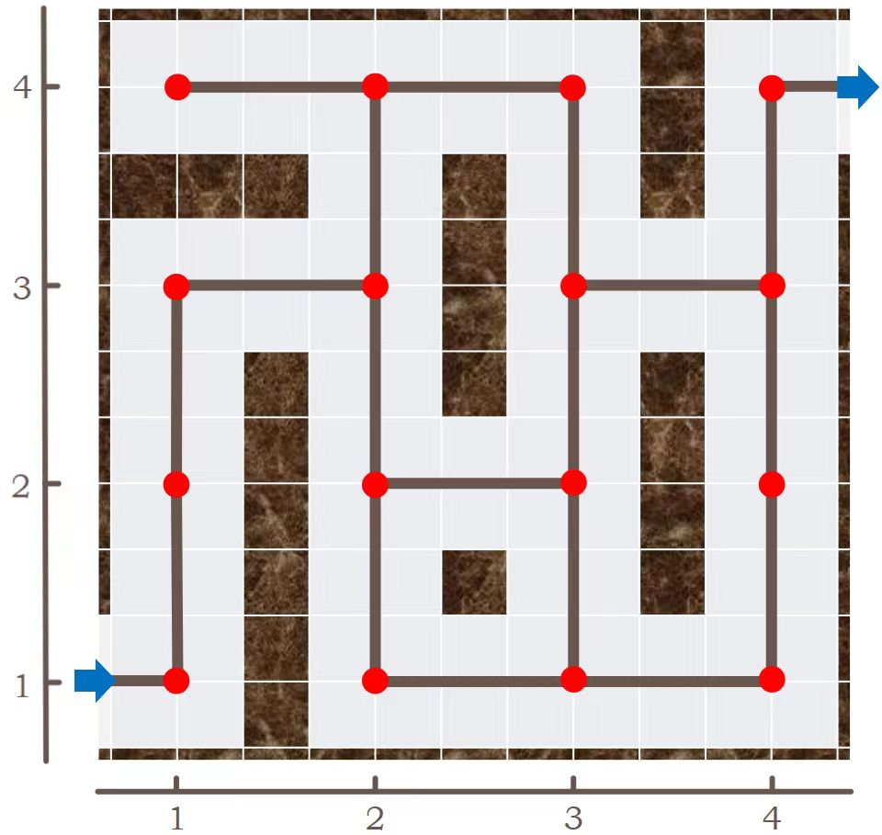
You should first read the following program implementation, and then fill the output of the program in the form. The status should be printed in the format "(row,column)" without quotes.
procedure BFS_Maze_Puzzle(InitState)
if InitState is the target state:
print “end” and return
Q = initialize an empty queue
push the InitState into Q
print InitState in the specified format
while (Q is not empty) do:
S = pop an element from Q
for D in [Left, Down, Right, Up] sequentially:
if there is such a block which can move D:
S’ = apply D to the block
if S’ has not been pushed to Q in the past:
print S’ in the specified format
if S’ is the target state:
print “end”
delete Q and return
else:
push S’ into Q

Example Output (from the initial state “(1,1)”)
Line 1 | (1,1)
Line 2 | (2,1)
Line 3 | end
Line 4

Your Answer
Line 1 | (1,1)
Line 2 | (2,1)
Line 3 | (3,1)
Line 4 | (3,2)
Line 5 | (2,2)
Line 6 | (4,2)
Line 7 | (1,2)
Line 8 | (2,3)
Line 9 | (4,1)
Line 10 | (4,3)
Line 11 | (1,3)
Line 12 | (3,3)
Line 13 | (1,4)
Line 14 | (3,4)
Line 15 | (2,4)
Line 16 | (4,4)
Line 17 | end

- (5’) In this question, we use the Manhattan distance to the target as a heuristic to solve the maze problem shown in the figure (the initial state is (1,1) and the target state is (4,4); Manhattan distance between (a,b) and (c,d) is: |a-c|+|b-d|.)

You should first read the following program implementation, and then fill the output of the program in the form. The status should be printed in the format "(row,column)" without quotes.
In this program, we use a data structure named priority queue, which can pop the element with the highest priority. In computer science, data structures such as heap, self-balancing binary search tree, etc. can all be implemented as priority queue. When comparing two states, the state with the smaller heuristic has a higher priority. If the heuristic of two states are equal, the state that was pushed into the priority queue later has a higher priority.

procedure A*_Maze_Puzzle(InitState)
if InitState is the target state:
print “end” and return
Q = initialize an empty priority queue
push the InitState into Q
print InitState in the specified format
while (Q is not empty) do:
S = pop the element with the highest priority from Q
for D in [Left, Down, Right, Up] sequentially:
if there is such a block which can move D:
S’ = apply D to the block
if S’ has not been pushed to Q in the past:
print S’ in the specified format
if S’ is the target state:
print “end”
delete Q and return
else:
push S’ into Q

Your Answer
Line 1 | (1,1)
Line 2 | (2,1)
Line 3 | (3,1)
Line 4 | (3,2)
Line 5 | (2,2)
Line 6 | (4,2)
Line 7 | (4,1)
Line 8 | (4,3)
Line 9 | (3,3)
Line 10 | (2,3)
Line 11 | (3,4)
Line 12 | (4,4)
Line 13 | end
Line 14
Line 15
Line 16
Line 17

